[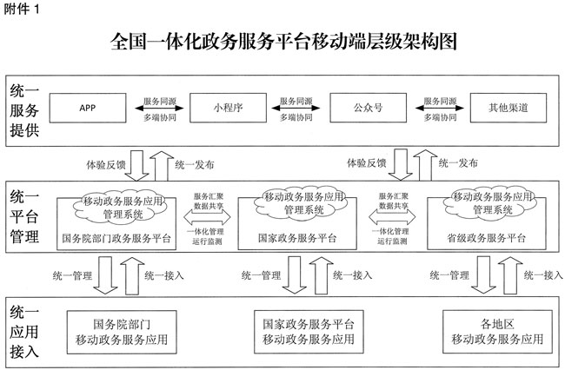](http://www.gov.cn/zhengce/content/jsjgt1.jpg)